How to deploy a Qt 5 Application

1. Build application for release

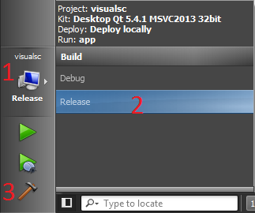

1. Open Visual Studio 2013 Developer Command Prompt   
   (this way windeployqt knows the visual studio directory)  
   C:\Program Files (x86)\Microsoft Visual Studio 12.0\Common7\Tools\Shortcuts\Developer Command Prompt for VS2013  
   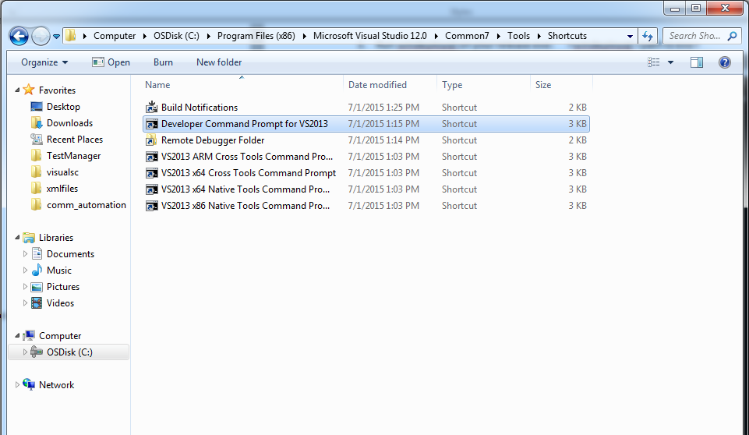
2. Run windeployqt on your release: >windeployqt <path to exe>  
   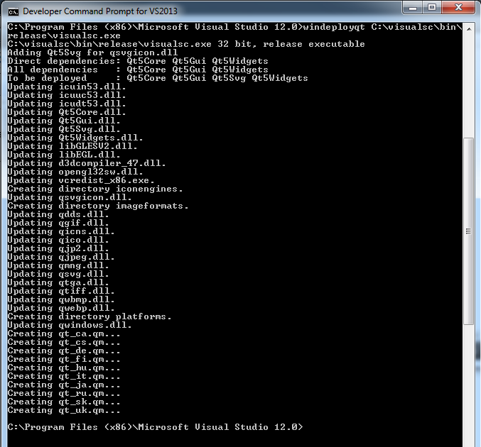  
   This command will copy all the dependencies and the installer for Microsoft Visual C++ 2013 inside your release directory.
3. **Missing Qt .dll:** one file that was not automatically created for me was Qt5OpenGL.dll. I had to copy it from the Qt directory in C:\Qt\Qt5.4.1\5.4\msvc2013\bin
4. Now you have a standalone, portable version. These are the files the program depends on :

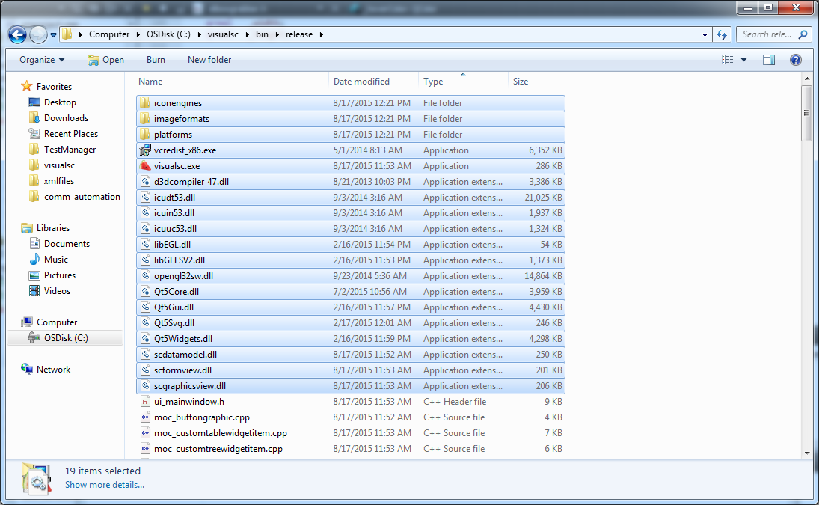

Continue to step 6 to create an installer using Visual Studio 2010

1. Creating an installer using Visual Studio 2010. Visual Studio 2010 is the latest version with built in installer projects. 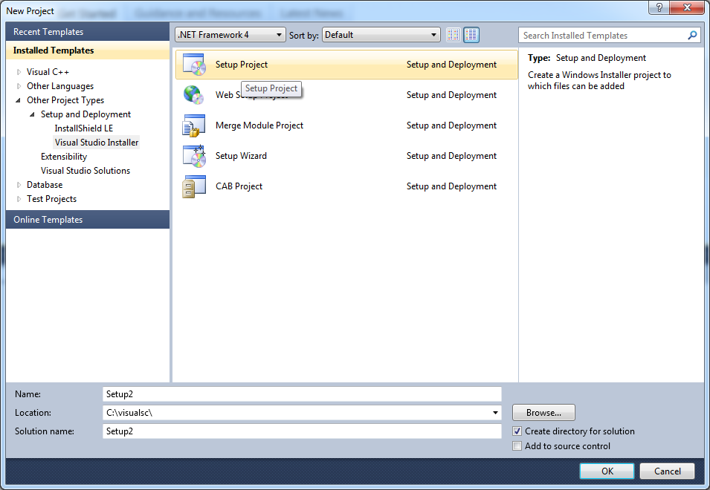
2. Change general properties of program by selecting the solution

* Author
* Manufacturer
* Product Name
* Version

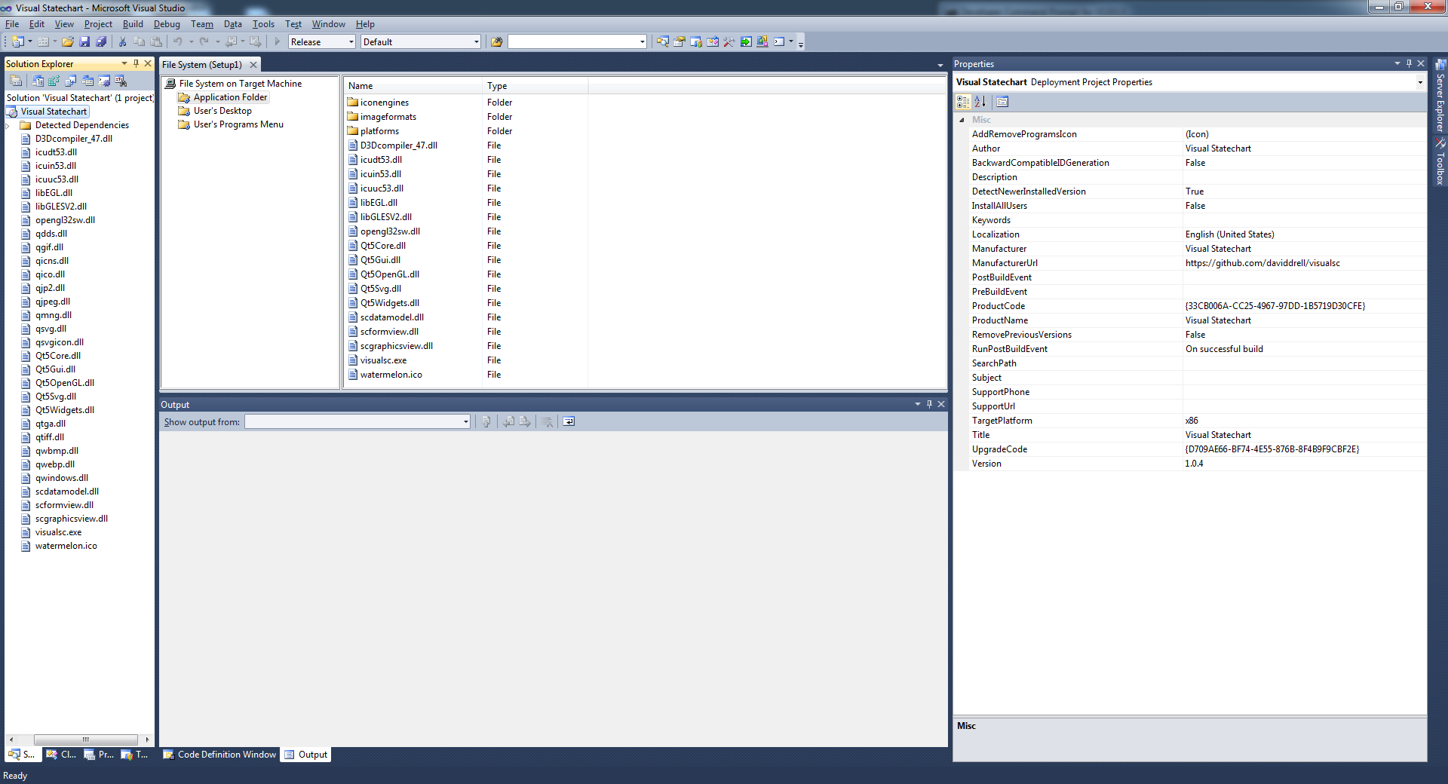

1. Add all the program files to the solution: right click > add > file

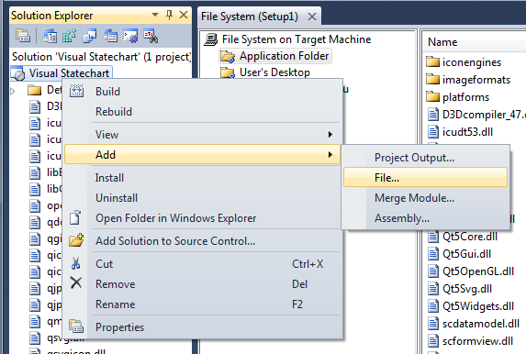

You must also match the folder structure of the dependencies by manually creating the folders in the application directory

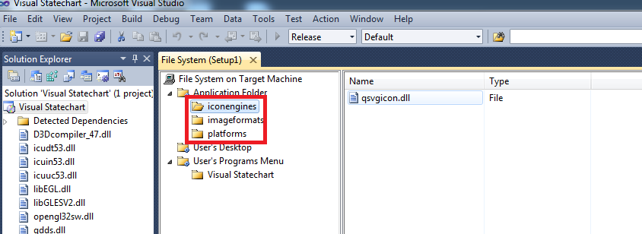

1. (Optional) shortcuts

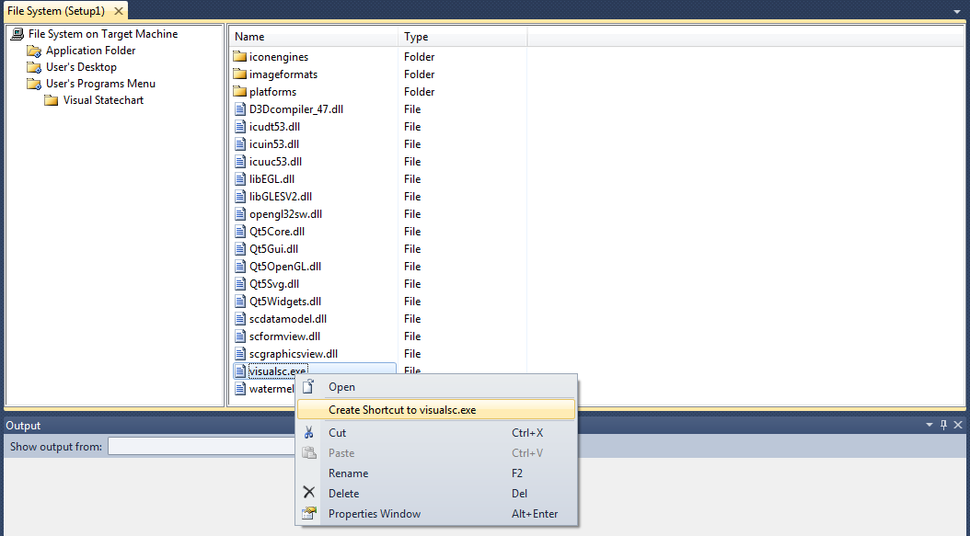

Create a start menu directory

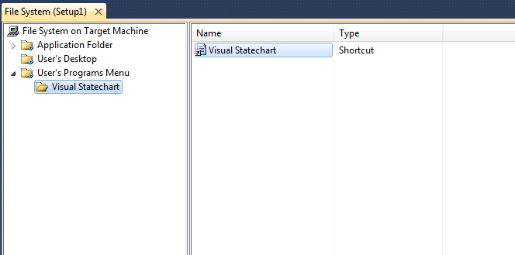

Set the shortcut’s icon  
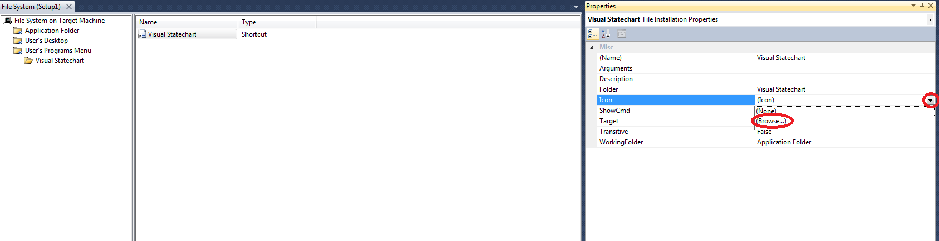

1. Change project build for release  
   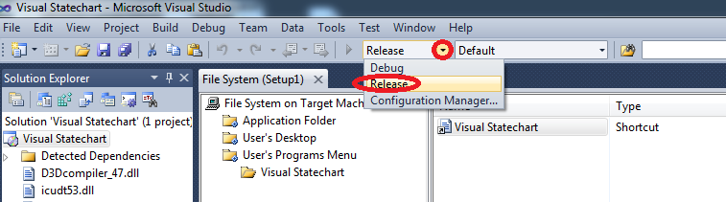
2. Build the solution  
   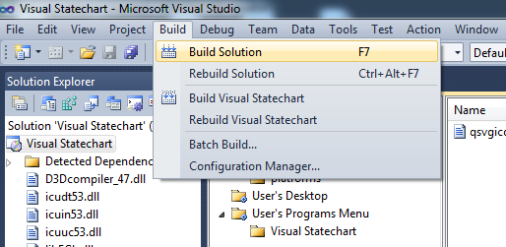
3. Go to the release folder to find the installer  
   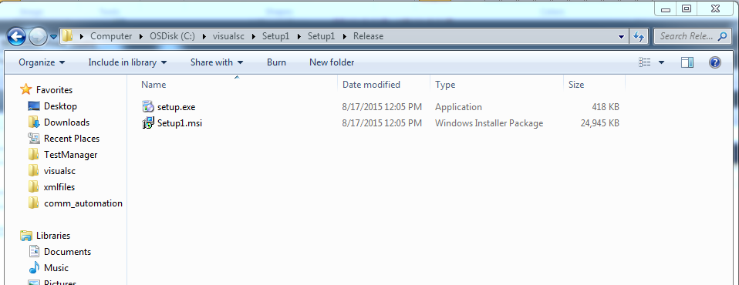
4. Make sure you also run the Microsoft Visual C++ 2013 Installer (vcredist_x86.exe) before running the program as this is also contains dependency. This package installer was created earlier with windeployqt. 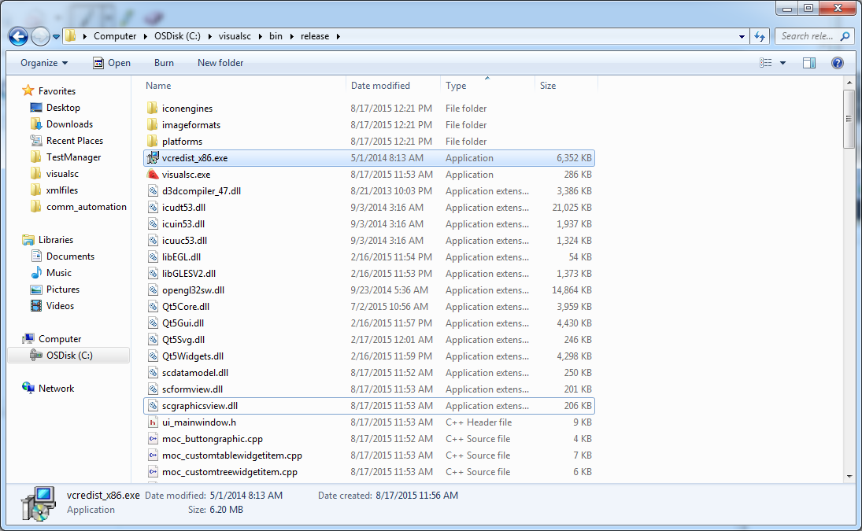
5. (Optional) zip both installers  
   